**PHENIKAA UNIVERSITY**

**FALCULTY OF ELECTRONIC ENGINEERING**

**BASIC PROGRAMMING FOR ELECTRONICS FINAL-TERM PROJECT REPORT**

**Project: Smart System utilize passive Infrared sensor to Control Fan and Light in smart home**

1. Duong Doan Tung

2. Nguyen Trong Huy Hoang

3. Le Hoang Nam

**HA NOI, 12/2022**

TABLE OF CONTENTS

Section 1: ABSTRACT 1

Section 2: PROJECT OVERVIEW 2

1. Inspiration 2

2. Basic Idea 2

Section 3: PROJECT DETAILS 4

1. Hardware 4

1.1. Electronic parts 4

1.1.1. USB-6255 4

1.1.2. HC-SR501 4

1.1.3. L298N 4

1.1.4. Light Emitting Diode 4

1.1.5. DC Motor 4

1.2. Wiring diagram 5

1.3. House model design 5

2. Software 5

2.1. Labview 5

2.1.1. User Interface 5

2.1.1.1. Manual control 6

2.1.1.2. Live feed tab 6

2.1.1.3. History tab 7

2.1.1.4. Schedule tab 8

2.1.1.5. TCP tab 9

2.1.1.6. ORM tab 9

2.1.1.7. Configuration tab 10

2.1.2. Labview block diagram 10

2.1.2.1. Program structure 10

2.1.2.2. Main VI block diagram 11

2.1.3. SubVIs 19

2.1.3.1. Error collector 19

2.1.3.2. Error handler 19

2.1.3.3. Simulation check 20

2.1.3.4. Retry TCP 20

2.1.3.5. Win32 decode IMG stream 20

2.1.3.6. String to GUID Cluster 21

2.1.3.7. Console Add 21

2.1.3.8. Get color 21

2.1.3.9. Change mode 22

2.1.3.10. Set data waveform 22

2.1.3.11. Manipulate output subVI 23

2.1.3.12. Create schedule 23

2.1.3.13. Sort schedule 24

2.1.3.14. Get time Epoch 24

2.1.3.15. Convert time & convert time down 25

2.2. Python Application 25

2.2.1. Purpose 25

2.2.2. Environment 25

2.2.3. The Optical recognition module 25

Section 3: RESULT 27

Section 4: CONCLUSION 28

1. Conclusion 28

2. Further development 28

Section 5: REFERENCES 29

**WORKLOAD DISTRIBUTION**

|  |  |
| --- | --- |
| Full name | Task |
| Duong Doan Tung | o Python, Labview Programming   * Edit video |
| Nguyen Trong Huy Hoang | * Setup hardware * Decorate, house design |
| Le Hoang Nam | * Write report * Build hardware |

Project include:

1. Project report
2. Presentation file and video
3. Python files
4. Labview files (18 subVIs included)

Full project material can be found here: <https://drive.google.com/drive/folders/15Gyvd-AxRdvlOK2FSbTaDAAlVZT9CAch?usp=sharing>

**Project repository:** <https://github.com/dtungpka/I.C.F.L>

*Special thanks to our teacher Dr. Huy Minh Le for his help in this project*

# Section 1: ABSTRACT

The use of classification algorithms for predicting cryptocurrency prices has gained significant interest in recent years. In this study, we investigated the feasibility of using three popular classification algorithms, namely Logistic Regression, Naïve Bayes, and K-Nearest Neighbors (KNN), to predict the direction of cryptocurrency prices with five classes. The direction of cryptocurrency prices was classified into small increase, large increase, small decrease, large decrease, and no change categories.

We used a dataset containing historical cryptocurrency price data and technical indicators. We evaluated the performance of each algorithm using accuracy, precision, recall, and F1 score metrics to determine which algorithm performed best in predicting cryptocurrency price direction with five classes.

The findings of this study could potentially assist investors and traders in making more granular and informed decisions in the cryptocurrency market. Our results showed that the KNN algorithm outperformed the other algorithms, achieving an accuracy of 0.55, precision of 0.54, recall of 0.54, and F1 score of 0.54. Overall, our study provides valuable insights into the use of classification algorithms for predicting cryptocurrency prices with multiple categories.

# Section 2: PROJECT OVERVIEW

## Inspiration

From cities and transportation to the resources we farm, emerging Internet of Thing (IoT) technologies are set to make everyday processes more integrated and easier. As the sensors, data storage, the Internet, and analytics become faster, cheaper, better, and more integrated together, users will be able to rely on smart system more. IoT devices will have a significant impact on many aspects of our lives including how we live, drive, and farm animals and crops.

The Internet of Things (IOT) technology establishes a connection between all things and the Internet via sensing devices and implements intelligent identification and management. The information sensing devices include infrared sensors, GPS and laser scanner devices. They are all connected to the Internet to implement remote perception and control. IOT is widely applied in intelligent transportation, environment protection, government work, public security, smart home, intelligent fire control, industrial monitoring, elderly care, personal health, etc.

With that in mind, we set our main objective to create a smart IoT system for smart home applications and called it **Smart System utilize passive Infrared sensor to Control Fan and Light in smart home (S.S.I.C.F.L)**, this is an upgrade from **using passive Infrared sensor to Control Fan and Light in**

**smart home (I.C.F.L)** mid-term project.

## Basic Idea

The system consists of 2 devices: a computer and DAQ USB-6255 device.

The computer will acquire sensor data, process and send signal to control the DAQ device. DAQ device is used to read Passive InfRared sensor (PIR) data, control LED and fan.

On computer, we can control DAQ device in 3 modes:

* Schedule mode: create schedules for fan and LED (FLED)[1] to work automatically at a defined time stamp
* Manual mode: allows users to control FLED manually in 2 ways:
  + On Labview Front panel
  + By finger using Optical Recognition Module (ORM)
* Realtime mode: Read data from PIR sensor and control FLED automatically.

# Section 3: PROJECT DETAILS

## Hardware

### Electronic parts

#### USB-6255

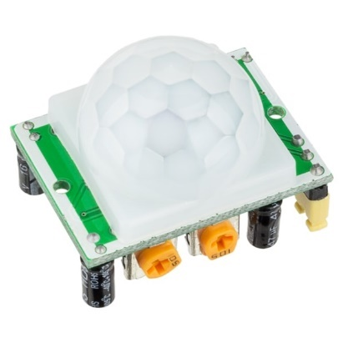USB-6255 is an 80 AI (16-Bit, 1.25 MS/s), 2 AO (2.86 MS/s), 24 DIO USB Multifunction I/O Device—The USB‑6255 offers analog I/O, digital I/O, two 32-bit counters/timers, and analog and digital triggering. The device delivers low-cost, reliable DAQ capabilities in a wide range of applications from simple applications in laboratory automation, research, design verification/test, and manufacturing test.

Figure 1. USB-6255 Device

#### HC-SR501

HC-SR501 is based on infrared technology, automatic control module, using Germany imported LHI778 probe design, high sensitivity, high reliability, ultra-low-voltage operating mode, widely used in various auto-sensing electrical equipment, especially for battery-powered automatic controlled products.

Figure 2.HC-SR501

#### L298N

The L298N is an integrated monolithic circuit in a 15- lead Multiwatt and PowerSO20 packages. It is a high voltage, high current dual full-bridge driver designed to accept standard TTL logic level sand drive inductive loads such as relays, solenoids, DC and stepping motors

#### Light Emitting Diode

A light-emitting diode (LED) is a semiconductor device that emits light when current flows through it. Electrons in the semiconductor recombine with electron holes, releasing energy in the form of photons.

#### DC Motor

A DC motor is any of a class of rotary electrical motors that converts direct current (DC) electrical energy into mechanical energy. The most common types rely on the forces produced by induced magnetic fields due to flowing current in the coil.

### Wiring diagram

Figure . Circuit schematic

We created a simple circuit that reads the PIR sensor input in Terminal 1: AI0 of USB-6255. FLED are controlled by Analog output terminal AO0, AO1 respectively. We use LM298 DC Motor Driver Controller to amplify the signal from DAQ to 9 volt and use it to control the Fan.

### House model design

## Software

### Labview

#### User Interface

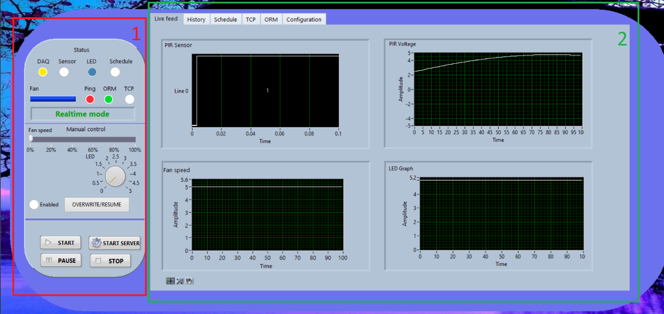

Figure . Labview user interface on live feed tab

The user interface (front panel) in UI Main.vi file can control every function of this project. It’s contained 2 parts[2]:

* Control panel (1) display status[3] of the program and control FLED manually.
* Tabs (2) contain live feed data from DAQ, TCP server and client information, ORM module and schedule mode control.

##### Manual control

User can control FLED manually by drag and drop the Fan speed slider and LED knob in Control panel. When those value changed, enable light will turn yellow if manual mode not enabled yet. Click on OVERWRITE/RESUME will turn on manual mode and apply change to FLED. Click on it again to resume to the previous mode and end manual mode.

Figure . Manual control interface

##### Live feed tab

Live feed tab show latest 100 datapoint in real time:

* PIR voltage is the raw data from DAQ
* PIR Sensor shows processed sensor data, 1 means passed the threshold, 0 mean below.
* Fan speed and LED graph show Output data to FLED.

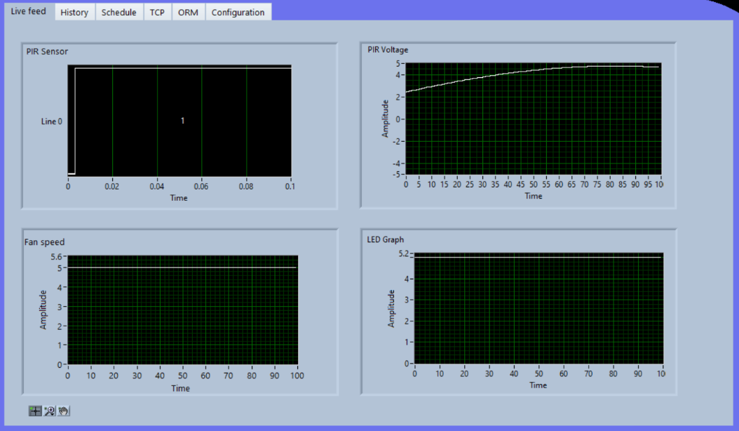

Figure . Livefeed tab

##### History tab

History tab show all data from current session, it can also save and load data.

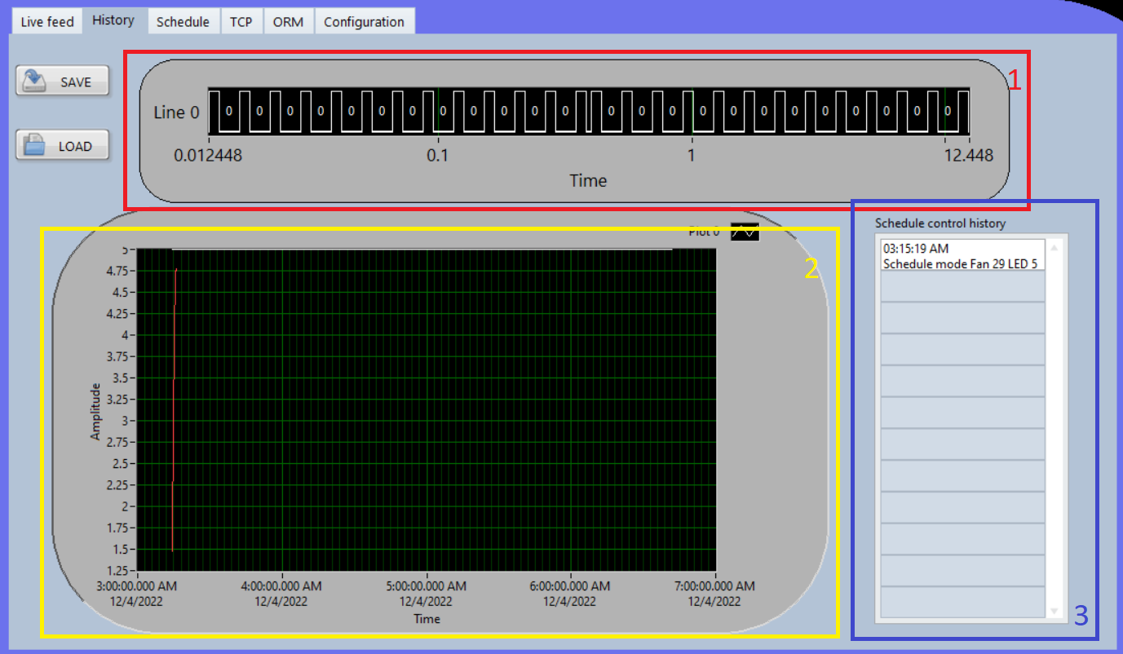

Figure . History tab

Graph (1) is PIR sensor data processed, (2) contain 2 lines: Red line is PIR sensor voltage level, white is FLED output data. (3) data table past schedule that executed.

##### Schedule tab

On schedule tab, user can create, modify, delete schedule. Available action are: Light on, Light off, Fan on, Fan off, All on, All off. After created, the schedule will appear on the pending list below in execute time order. Switch on Enable button will change program to schedule mode and each pending schedule will display their time till activation[4]. After activated, the schedule will be deleted.

Figure . Schedule tab - Disabled

Figure . Schedule tab – Activated

##### TCP tab

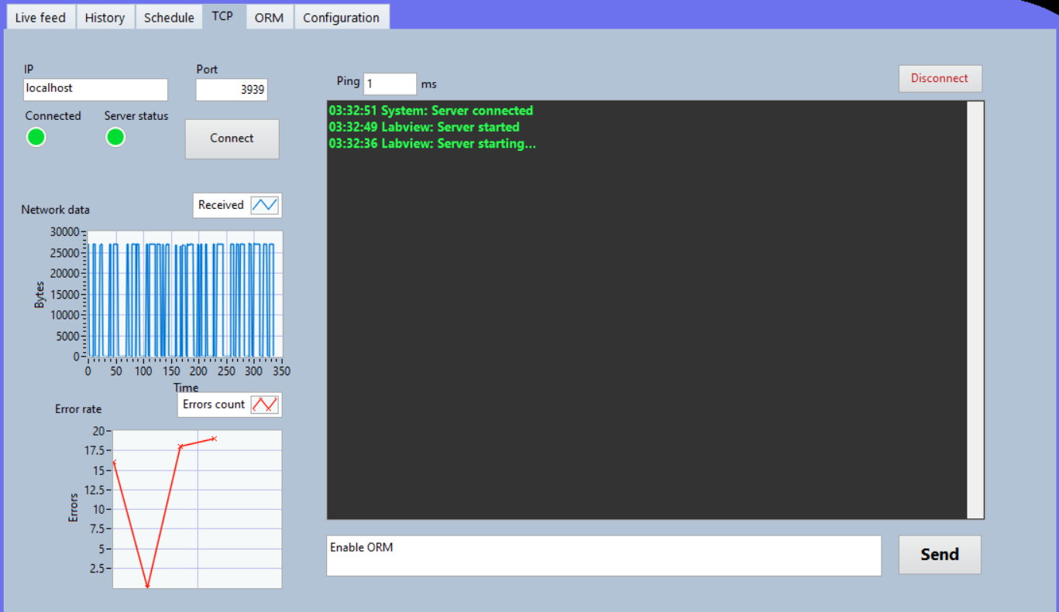

Figure . TCP in action

TCP tab shows TCP connection status between Python server and Labview.

##### ORM tab

Figure . ORM no signal

ORM tab show MJPEG video stream from python server through ’OMF’ command. Fan value and Light value is from server through ’OMV’ command.

##### Configuration tab

Configuration tabcontain all setting available:

* DAQ device and PIR input terminal choose
* PIR threshold, time before Fan turn off. etc.

Figure . Configuration tab – default value

#### Labview block diagram

##### Program structure

This project contain 1 main VI and 21 subVIs, along with 7 typedef. Files and 1 global variable file.

Figure 13. Typedef list

Figure .Main VI, subVIs list

##### Main VI block diagram

We can break the block diagram into 2 parts for better demonstration: Main block (2) and an event handler (1).

Figure . Main UI block diagram

###### Main block

The main program is Flat sequence structure. It contain 3 frame which execute in order from left to right.

Setup frame

Figure 16. A part of setup frame

The first frame to set up all required variables for each run. This frame will run each time the user presses the Run button.

Variable include: Button, Indicator color, Global ignore error list code, Data value ref, Initial video feed image.

This also set the default mode to Realtime mode.

Simulation mode handling

Figure . Frame 2

The second frame is to check DAQ connection and determine whether to run in simulation mode or not: It tries to send a signal to turn on FLED to the DAQ, the error out from DAQ write wired to simulation check to handle the error.[5]

Diagram . Simulation mode

Program main loop

Figure . Main while loop

Inside the last frame is 4 case structure, when the user run the program, the first 3 case will execute in parallel with each other:

Case (1) is for computing and process schedule.

Figure . Case (1) - Schedule

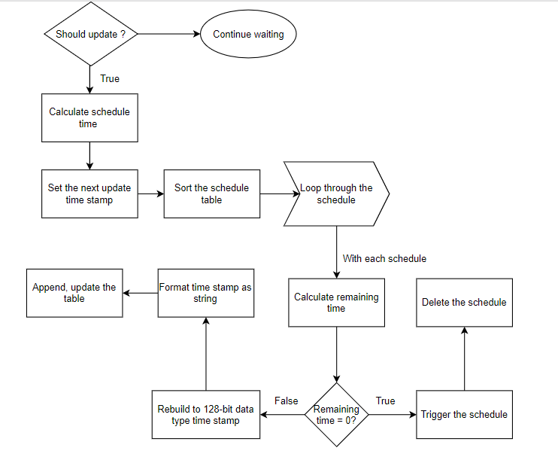

Diagram . Update schedule

Case (2) read the sensor data continuously:

* The data from DAQ was then sent to 3 independent sections: Manipulate Output sub VI, show waveform on Live feed tab, save data on history tab.
* Manipulate sub VI handle everything needed to control light and fan.
* Set waveform sub VI create and combine data to show as waveform on Live feed tab.

Figure . Realtime mode

Diagram . Realtime data acquisition

Case (3) is TCP client data handling block. This case controls all TCP data in and out from the server to Labview client.

Figure . TCP ready state

Each time we receive data from the server, we need to check for error in connection and data integrity. After verify the data, OK code is send back to the server.

Figure . TCP data filter, classify

If we discover any error with the connection or data doesn’t match, TCP connection is restarted.

Figure . TCP error handing, Network stats acquire

Ping graph is calculated by subtracting the time when command ends with the command start time. Error rate is the time connection restart per 2000ms.

Figure . TCP client - simplified

TCP restarting procedure:

Diagram . TCP restart

Case (4) is for checking server started state.

###### Event block

The event block contains 20 Event:

1. Save to file:

Write data from history tab to a file

1. Load file:

Read data from file and display to history tab

1. Stop:

Stop the program

1. Reset value:

Using VI server Invoke node to call Default Vals.Reinit All

1. Restart VI:

Call App.restart Invoke node

1. Simulating:

Set the local simulating state to global

1. Start:

Recover from Pause state by set Running to True

1. Pause:

Temporary pause the program by set Running to false

1. Manual mode resume:

Change current mode to Manual mode and enable manual control

1. Connect:

Get the current control IP, Port and attempt to connect to TCP server

1. Start server:

Call python PythonApplication.py in cmd using System Exec.vi

1. Manual mode:

Change the manual in ORM tab

1. Fan speed, LED value change (joint event):

Manually change the FLED output.

Diagram . FLED value change

1. Clear schedule:

Clear the pending schedule

1. Set schedule:

Create a new schedule

1. Enable schedule:

Change program to schedule mode

1. Schedule LED:

Change the Schedule indicator on control panel

1. Reset device:

Reset the DAQ programmatically

1. Remove schedule:

Remove the schedule with ID

1. ID value change:

Update the Change schedule value when change ID control.

#### SubVIs

In our project, SubVIs play an **essential role** which make program up and running perfectly, 60% of Labview our code is in SubVIs.

##### Error collector

Figure . Error collector

Error collector subVI is used to collect error for Error handler subVI.

##### Error handler

Figure . Error handler

Error handler print out error and ignore error in Ignore error global list

##### Simulation check

Figure . Simulation check

This subVI check and prompts the user to turn on simulation mode or not.

Simulation mode is used when DAQ device is not available, this require simulated USB-6255 device in NI MAX.

##### Retry TCP

Figure . Retry TCP

This subVI restarts the TCP connection.

##### Win32 decode IMG stream

Decode JPEG string from TCP stream using CLFN blocks (ole32, windowscodecs and shlwapi calls)

##### String to GUID Cluster

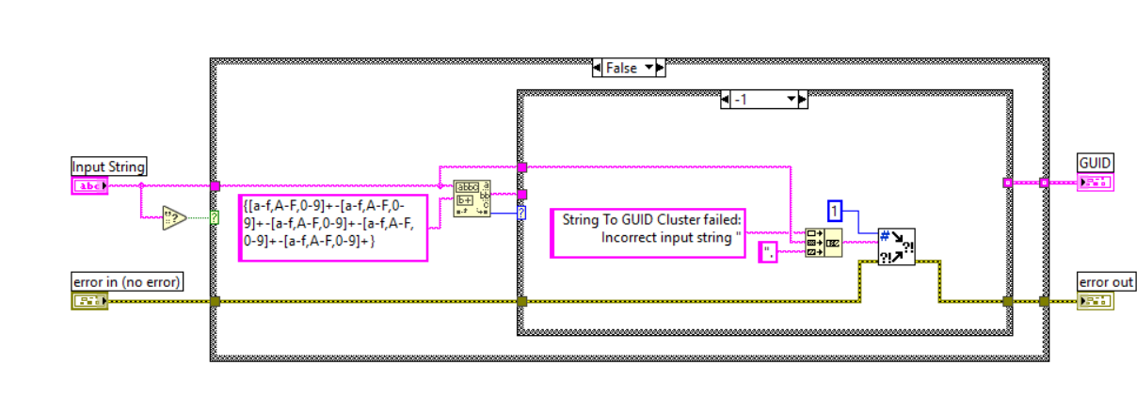

Figure . GUID

Part of Win32 decode IMG stream, convert string to GUID cluster.

##### Console Add

Figure . Console

Format the console input and display it in TCP tab, similar to print() function.

##### Get color

Figure . Get color

Get color cluster from defined color Enum, build into array for easy Property node color change.

##### Change mode

Figure . Change mode

Change the current mode to Set mode and Previous mode to current mode.

##### Set data waveform

Figure . Set data waveform

This subVI get the input waveform, append it with input data and return appended waveform and a sub waveform that contains the first [waveform datapoints] value.

##### Manipulate output subVI

This subVI control all write operations to the DAQ, it process data from PIR sensor and calculates time to turn FLED on/off, speed, how long it stay on, voltage to write.

Diagram . Manipulate output subVI - simplified

##### Create schedule

Figure . Create schedule

Create a new schedule , add to global schedules list and sort it.

Diagram

##### Sort schedule

Similar to create schedule subVI, but only loop through the global schedule list and sort it.

##### Get time Epoch

Figure . Epoch

When converting Labview 128-bit time stamp data to LVDataTimeRec type, because LabVIEW timestamp significant 64 bits interpreted as a 64-bit signed two's complement integer represents the number of whole seconds after the Epoch, while LVDataTimeRec is a cluster contain time from year 0. So to get the correct time stamp we need to convert to Epoch. This subVI return 2 LVDataTimeRec: To Epoch and From Epoch.[6]

##### Convert time & convert time down

Figure . Convert time

This subVI check and converts the LVDataTimeRec value. For example, 62 seconds will be converted to 1 minute 2 seconds.

LVDataTimeRec will be unpack and convert into a array of 7 element, with the last element is 0. Then we loop through all element and with each element: compare the value with a pre-defined constant array containing maximum value allowed on each element (in order: second, minute, hour, day of month, month). And if the element exceeds this value, a while loop will subtract the element and increase the next element value by 1. This continue till the end of list.[7]

### Python Application

#### Purpose

In this project, we used Python as a server to run the optical recognition module and send MJPEG video stream to LabVIEW.

#### Environment

We use Python 3.9 (64-bit) on windows 11 machine with 1280x720 30 fps integrated camera.

CPU: Intel(R) Core(TM) i5-10300H CPU @ 2.50GHz, 2496 Mhz, 4 Core(s), 8 Logical Processor(s)

Total Physical Memory: 11.9 GB

TensorFlow is configurated to run on: NVDIA GeForce GTX1650ti Integrated card.

#### The Optical recognition module

# Section 3: RESULT

# Section 4: CONCLUSION

## Conclusion

## Further development

# Section 5: REFERENCES

1. <https://www.ni.com/docs/en-US/bundle/pci-pxi-usb-6255-specs/page/specs.html>
2. <https://www.ni.com/en-vn/support/model.usb-6255.html>
3. <https://forums.ni.com/t5/Example-Code/Programmatically-Reset-VI-Example/ta-p/3532614>
4. <https://forums.ni.com/t5/LabVIEW/Error-363507-LabVIEW-could-not-verify-the-authenticity-of-the/td-p/2881254>

[5]<https://www.google.com/url?sa=t&rct=j&q=&esrc=s&source=web&cd=&cad=rja&uact=8&ved=2ahUKEwjpm4a1g_76AhUrq1YBHYFkC70QFnoECBEQAQ&url=https%3A%2F%2Fwww.sparkfun.com%2Fdatasheets%2FRobotics%2FL298_H_Bridge.pdf&usg=AOvVaw0wIXqbF0WzC_SUFkv1WstB>

1. Fan and LED
2. Figure 4
3. For more information, see Appendix B
4. Figure 9
5. For more info see section 2.1.3.3
6. https://knowledge.ni.com/KnowledgeArticleDetails?id=kA03q000000YKVgCAO&l=en-VN
7. The last 6 least important subVI will not be included in this report. For more information, see the source code.